

**Table of Contents**

Introduction 3

1. Audience 4

1.1. Overview 4

1.2. Demographics 6

1.2.1. Age and Gender 6

1.3. Geo 7

1.3.1. Language and Location 7

1.4. Technology 9

2. Behavior 9

3. Business Goals 10

3.1. Business Goal 1: Convert non-members to members 11

3.1.1. Awareness stage 12

3.1.2. Consideration Stage 15

3.1.3. Conversion Stage 16

3.2. Business goal 2: Launching a new location 16

3.3. Business Goal 3: Selling summer-camp programs 17

3.3.1. Leads and Goal Overview 17

3.3.2. Events 18

3.3.3. Google Ads and Benchmarking 19

3.4. Business Goal 4: Generating revenue through affiliate marketing 21

3.4.1. Page Speed Insights 21

3.4.2. Filters 21

3.4.3. Segments 22

4. Google Looker Studio Report 23

5. Recommendations 24

Conclusion 25

Bibliography 26

Annex 27

**Table of** **Figures**

Figure 1 - Website Audience Overview 4

Figure 2 - Website Audience Overview - Comparison with the previous period 5

Figure 3 - Audience Demographics Overview - Age and Gender 6

Figure 4 - Audience Demographics – Gender by Age 7

Figure 5 - Audience Top 10 Language 8

Figure 6 - Audience Top 10 Country 8

Figure 7 - Audience Top 10 Cities of USA 8

Figure 8 - Technology and Mobile - Cross Analysis 9

Figure 9 - Behavior - New Users vs Returning Users 10

Figure 10 – Marketing Funnel 12

Figure 11 - User's Behavior Flow on the Website 13

Figure 12 - CourtSense Social Network Analysis 14

Figure 13 - Flowpage - Linking Instagram to CourtSense Website 14

Figure 14 - Facebook Pixel 15

Figure 15 - Behavior - Top Events 15

Figure 16 - Comparison between E-mail Marketing and WhatsApp Marketing Analysis by Vimos 16

Figure 17 - Goal Completions Analysis 17

Figure 18 - 1st Step of the Funnel after clicking the CTA “Get my FREE GUIDE Now!” 18

Figure 19 - All Goals - Goal 1: Junior Tennis Leads tracking problem 18

Figure 20 - Event Action per Page 19

Figure 21 - CourtSense Website performance vs Benchmark Analysis 19

Figure 22 - Summer Camp Campaign Performance Analysis 20

Figure 23 - Keyword Research output from WordTracker 20

Figure 24 - Keyword Research output from WordStream 21

Figure 25 - Google Analytics IP Address View Filter 22

Figure 26 - Tennis Court IP Address 22

Figure 27 - Segments 22

**Table of Tables**

Table 1 - Analytics Framework 11

**Table of Annexes**

Annex 1 - Audience Demographics - Age (detailed) 27

Annex 2 - Audience Demographics - Gender (detailed) 27

Annex 3 - Technology - Top 10 Browser Analysis 27

Annex 4 - Technology - Top 10 Device Analysis 27

# Introduction

As digital analysts with a background in using Google Analytics, we are excited to dive into the data from the tennis membership website and provide a technical and in-depth analysis of its digital performance over the period November 1st, 2021, to November 1st, 2022. Utilizing the wealth of information available through Google Analytics, we will examine key metrics such as visitor demographics, traffic sources, user behavior on the site, and conversion rates to gain a comprehensive understanding of the website's performance.

By leveraging the latest technologies and techniques in data analysis, we will also delve into trends and patterns in the data to identify opportunities for growth and optimization. Whether it's implementing targeted marketing campaigns or optimizing the user experience on the website, we will provide recommendations for enhancing website awareness, conversion rates, overall performance, and user engagement.

While data analysis can sometimes be technical and complex, it's important to remember that it's all in service of understanding and improving the user experience. By continuously monitoring key performance indicators (KPIs) and implementing strategic actions based on our analysis, we can help the tennis membership website achieve its business goals and drive long-term success, all while having a good time doing it.

# Audience

## Overview

To carry out this report, the period of analysis was from **November 1st, 2021, to November 1st, 2022**. During this period, the website received a total of 30,903 users, of which 30270 were new users, performing a total of 44,571 sessions and having 88550 pageviews, over the course of the year-long period of analysis. In order to understand if these values ​​are significant, that is, if these values ​​are positive for the website and for the business, it is also important that we focus part of our attention on understanding the quality of the traffic obtained, namely, the visitor’s experience on the website. 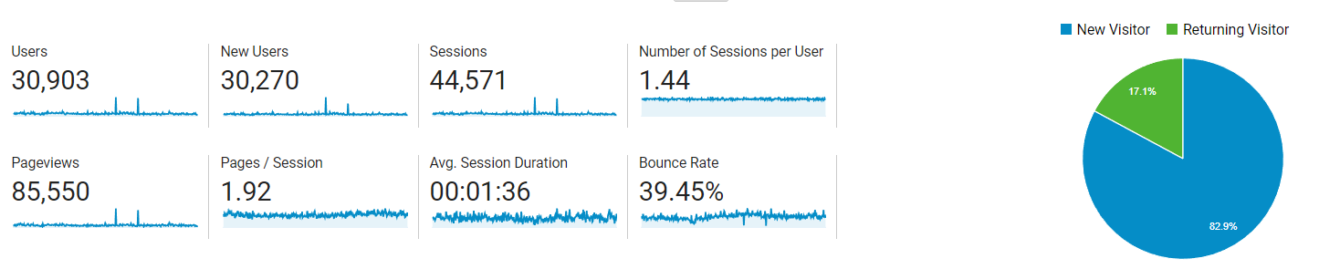

Figure - Website Audience Overview

To analyze the interactions with the website, there are several metrics that we can focus on. Starting by analyzing the Bounce Rate, we can see that it the website had 39%. Taking this percentage into account, we can say that the bounce rate is a little high, and that one of the company's future goals could be to try to reduce it. It is important to note that this value is still not very worrying, even though, it is a little high, as companies must bet on having a bounce rate of up to 30%. Having a **39% bounce rate**, means that 39% of website visitors just opened the page and left, without any kind of interaction with the website, since CourtSense website doesn’t have just one page.

One potential reason for a high bounce rate could be a poor user experience on the website. This could include issues with website navigation, slow loading times, or a lack of relevant or engaging content. In order to address this issue, it may be helpful to conduct a user experience (UX) audit to identify any specific areas of the website that may be causing visitors to leave. This could involve reviewing website design and layout, analyzing website traffic data to understand how visitors are interacting with the site, and gathering feedback from website users to identify any pain points or areas for improvement.

In addition to the high bounce rate, the data also shows that the average length of a session on the website is 1 minute and 36 seconds, and the average number of pages viewed during a session is 1.92. These metrics suggest that visitors to the website are not spending a significant amount of time on the site and are not engaging with multiple pages. This could be a sign that the website is not effectively capturing the interest of its visitors or providing them with a compelling reason to stay and explore the site further.

A further indication of the quality of website engagement is the percentage of **returning visitors**, which stands at **17%, being relatively low** when compared to the nearly 83% of new visitors. Additionally, the data shows that 84% of all company-defined goal completions on the website are attributed to **new visitors**, compared to just 16% for returning visitors. Although conversion rates aren't high, it is also possible to comprehend that new visitors have a higher conversion rate than returning visitors. This suggests that the website may be more effective at converting new visitors into customers than it is at retaining and engaging returning visitors.

One potential reason for this difference in conversion rates could be a lack of incentives or benefits for returning visitors. This could include a lack of personalized recommendations or offers, or a lack of fresh or engaging content that encourages returning visitors to continue using the website. In order to address this issue, it may be helpful to focus on creating a more personalized and engaging experience for returning visitors. This could involve using customer data and behavior to create targeted recommendations or offers or implementing features such as loyalty programs or referral incentives to encourage returning visitors to continue using the website.

Additionally, the data shows that several key metrics tracked by Google Analytics, such as pageviews (-8.92%), average session duration (-8.01%), and pages per session (-6.70), have declined over the period of analysis. The only exceptions to this trend are the bounce rate, which has decreased by nearly 4%, and the number of sessions per user, which has increased by 2.38%. It is worth noting that these declines may be due to the ongoing pandemic, which could have affected website traffic and user behavior.

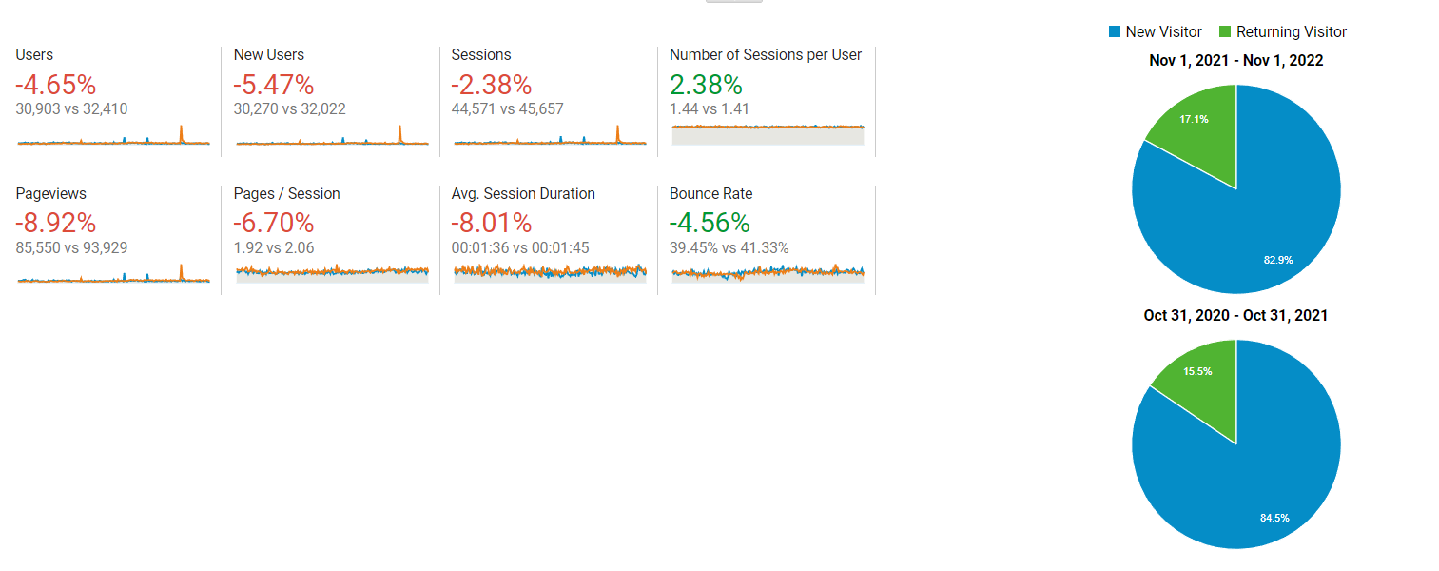

Figure - Website Audience Overview - Comparison with the previous period

The provided overview data evidently indicates that there is a need to improve overall website engagement even though several users are already aware of CourtSense and its website.

In order to improve these metrics, it may be helpful to focus on improving the overall user experience on the website. This could include optimizing the website for mobile devices, improving the design and layout of the site to make it more visually appealing and user-friendly, and creating engaging and relevant content that encourages visitors to stay and explore the site further. Additionally, it may be helpful to consider implementing marketing and engagement tactics such as email marketing or social media campaigns to drive more traffic to the site and encourage visitors to spend more time on the website.

The data suggests that there is room for improvement in terms of the website's bounce rate, session duration, and number of pages viewed per session. By focusing on improving the user experience and implementing targeted marketing and engagement strategies, it may be possible to improve these metrics and drive more value for the business.

## Demographics

### Age and Gender

CourtSense’s website users, during the period in analyzation, were mainly from 35-44 **(26.69%),** 25-34 **(21.57%)** and 45-54 **(20%)** age groups, which together represent more than 68% of total users. Additionally, the same age groups represented 26.88%, 23.75% and 21.25% of total goal completions, respectively. Further, the data shows that 55.4% of the website users are male and 44.6% are female. One key finding from this data is that **male** users are more likely to engage with the website, as they represent a larger proportion of total users and perform more sessions, pages per session, and have a lower bounce rate compared to female users. However, **female** users appear to have a higher average session duration, conversion rate, and goal completion rate compared to male users.

One potential explanation for these differences could be the types of content and offers that are more appealing to male versus female users. It may be helpful to conduct further analysis to understand the specific interests and preferences of male and female users, and to tailor the website's content and offers accordingly. This could involve using customer segmentation techniques to identify distinct groups of users with similar characteristics and preferences and creating targeted marketing campaigns and offers that are designed to appeal to these specific groups.

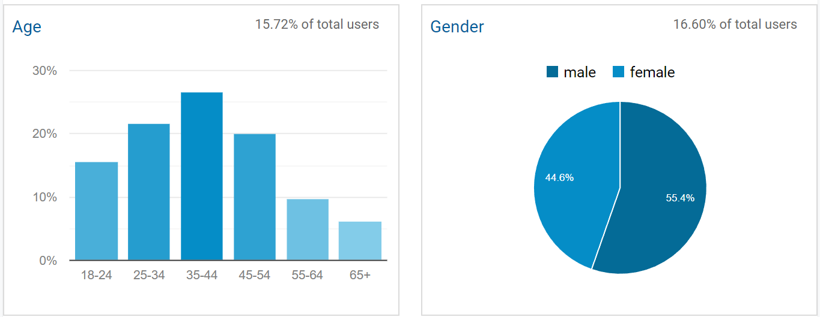

Figure - Audience Demographics Overview - Age and Gender

By performing a breakdown by gender, as a primary dimension, and age, as a secondary dimension, it is possible to understand that the biggest percentage of users coming to the website were **male from 35 to 44 age group**, representing 14.52% of the total users in study. This demographic was also responsible for the most goal completions (15.62%).

**Male from 25 to 34 age group** represented the second most important website demographic, being 12.24% of the total sample percentage and 13.12% of the goal completions.

The third most important website demographic corresponds to **female from 35-44 age group**. This demographic represented 12.16% of the total users and it was responsible for 11.25% of goal completion. This specific demographic had the lowest bounce rate (37.61%).

Additionally, it is worth noting that the data provided represents only a sample of the total website audience, as Google Analytics uses sample data for these reports. In order to gain a more complete understanding of the website's audience, it may be necessary to use Google Analytics 360 or other tools that provide access to more comprehensive data.

Overall, the data suggests that there are significant differences in the characteristics and behavior of male and female website users, and that it may be beneficial to tailor the website's content and offers to better meet the needs and preferences of these different groups. By conducting further analysis and implementing targeted marketing campaigns, it may be possible to improve overall engagement and conversion rates on the website.

Figure - Audience Demographics – Gender by Age

## Geo

### Language and Location

According to the data provided, the majority of CourtSense website users have their browser language settings set to American English (78.25%), while 10.36% of users had browser language settings that were not detected. This is consistent with the company's focus on serving users in specific areas of the United States.

The data also shows that the majority of website sessions (85%) are originating from the United States, with smaller proportions coming from Germany (1.18%) and China (1.12%). However, both countries have a high bounce rate, indicating that the traffic from these locations may not be highly qualified.

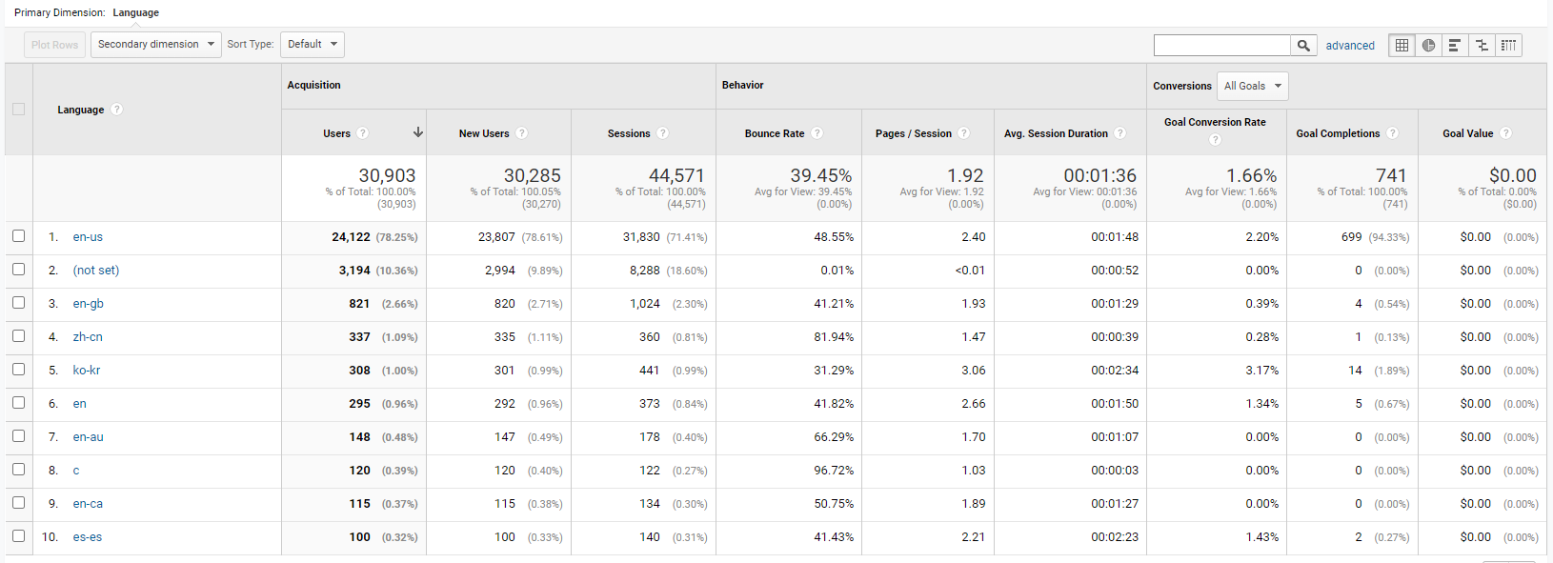

Figure - Audience Top 10 Language

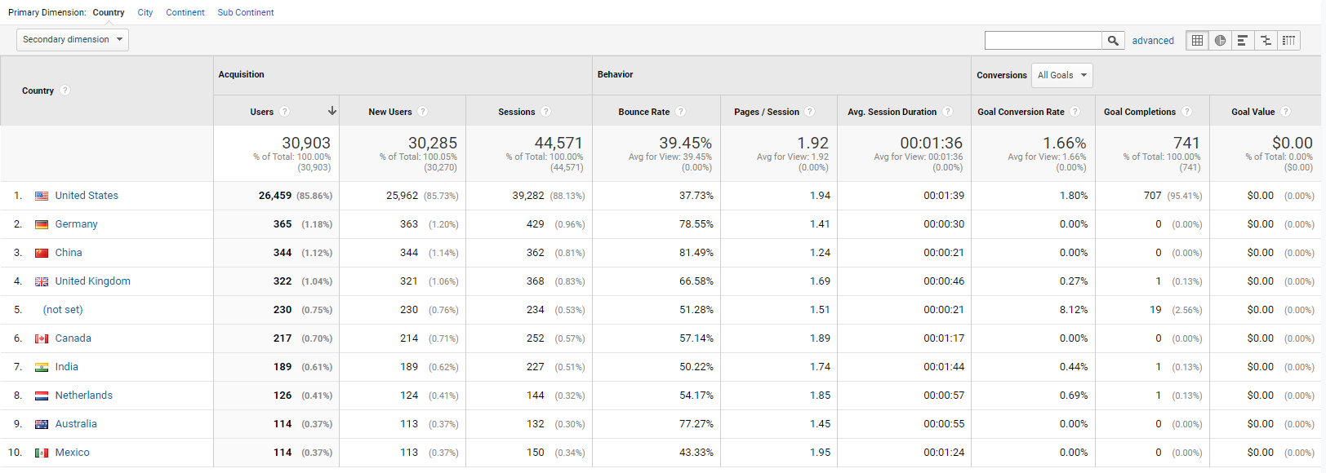

Figure - Audience Top 10 Country

To understand if many sessions were coming from the locations where CourtSense operates, we did a secondary dimension by city, where we verified that most of the users were from New York (20.30% of the total users). This is likely due to the company's tennis courts being located closer to New York, in Tenafly and Bogota cities from Jersey City. However, the data also shows that only a small proportion of website sessions are coming from Tenafly (1.62%) and Jersey City (1.51%), suggesting that there may be an opportunity for the company to consider opening a new court in New York.

Based on this data, it is clear that the website is primarily serving users in the United States, with a particular focus on the New York area. However, there may be opportunities to expand the website's reach and target new markets, particularly if there is a high demand for tennis memberships and physical courses in these areas. This could involve conducting market research to understand the specific needs and preferences of potential customers in different locations, and developing targeted marketing campaigns and offers to attract new users.

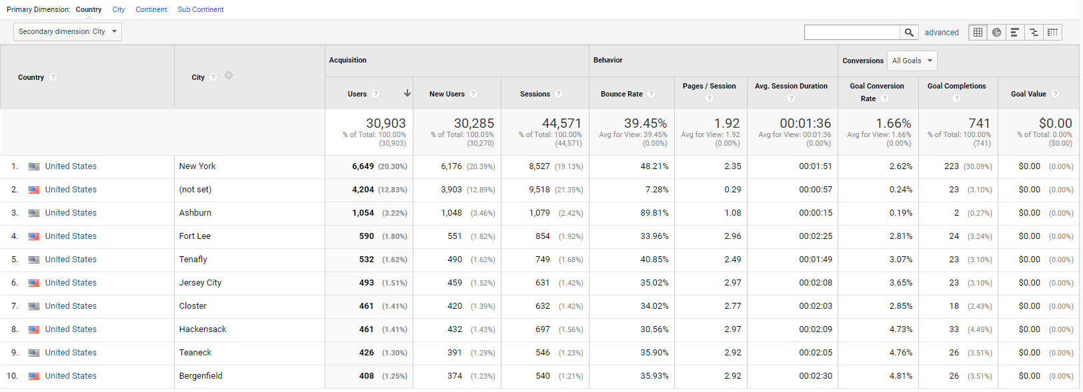

Figure - Audience Top 10 Cities of USA

## Technology

While analyzing Technology report that gives information on the most popular browsers used by most users, it shows that most of the users are using Safari (42.28%) to access the website, followed by Chrome (38.70%), representing over 80% of the total users. These two browsers, also account for the majority of goal completions (95%) - 53.04% from Safari and 42.65% from Chrome.

In terms of device usage, the data shows that slightly more users are accessing the website through **desktop (49.97%)** compared to **mobile (48.89%)**. Desktop usage is responsible for bringing in more sessions, users, and lower bounce rate, while mobile displays a higher percentage of new users, higher pages per session, conversion rate, and goal completions (60.19% versus 39.27% from desktop).

A cross-analysis of browsers and devices, in the figure below, reveals that 35.11% of all users accessed the website through the Safari browser on a mobile device, while 27.51% did so through Google Chrome on a desktop. This data highlights the importance of mobile devices for the business, as users who browsed the website on a mobile were more likely to complete goals.

Based on this data, it is clear that the majority of website traffic is coming from users accessing the website on desktop and mobile devices through the Safari and Chrome browsers. To optimize the website's performance, it may be helpful to focus on improving the user experience and engagement for these specific groups of users, perhaps by optimizing the website for these particular browsers and devices. Additionally, it may be worth considering the development of mobile-specific marketing campaigns and offers that are designed to appeal to mobile users and drive more conversions and goal completions.

Figure - Technology and Mobile - Cross Analysis

# Behavior

The data provided on the behavior of returning visitors to the CourtSense website, reveals that these users represent a relatively **small proportion** of the total website audience (17.14%). When compared to new visitors, returning visitors spend **less time** on the website (1.29 minutes versus 1.40 minutes), view **fewer pages per session** (1.31 versus 2.21), and have a **lower conversion rate** (0.85% versus 2.04%). However, its bounce rate is slightly high (35.46%) but comparatively lower to new visitors (41.33%). Additionally, returning users are responsible for a smaller proportion of goal completions (16.46%) compared to new visitors (83.54%). **Therefore, these findings suggest that returning visitors may be coming back to the website to check specific information, such as the location of courts or the company's contact information but are less likely to convert into leads.** This may indicate a need to improve the user experience for returning visitors and provide them with more personalized and engaging content and offers that are tailored to their specific interests and needs.

One potential strategy for improving the percentage of returning visitors could be to implement retention marketing campaigns that are designed to encourage these users to come back to the website and engage with the company's products and services. This could involve offering special discounts or promotions to returning visitors or providing them with exclusive content or offers that are not available to new visitors. By providing more value to returning visitors and making them feel appreciated and valued, it may be possible to increase the percentage of returning visitors and drive more value for the business.

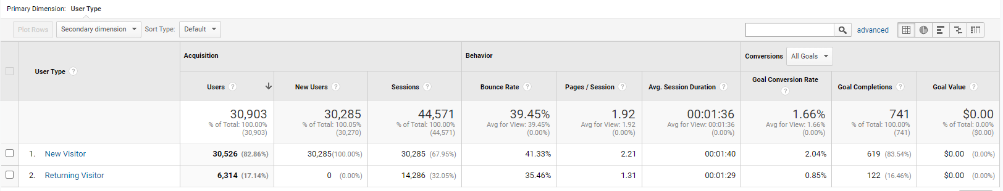

Figure - Behavior - New Users vs Returning Users

# Business Goals

|  |  |  |  |
| --- | --- | --- | --- |
| **Business Goal** | **Strategic Goal** | **KPI** | **Segment to be analyzed** |
| Convert non-members to members | Place blog content communicating membership benefits, social media | bounce rate / number of scrolls/ time on page /conversion rate / returning visitor | Visitors from New Jersey |
| Increasing audience engagement in social media | Engagement rate | Non-members from customer database (occasional customers) |
| Launching a new location | Raising awareness of the new spot - Paid advertisement campaign | CTR/ Number of new visitors / engaged sessions/ bounce rate | Paid traffic (targeted segment by interests and geo) |
| Creating website content about new spot | time on page / bounce rate | Total visits |
| Newsletters | CTR/ number of page visits / calls | Customers from database |
| Place new location on maps via google my business | Number of page visits / calls / reviews | New visitors |
| Selling Summer Camp program | Raising awareness of the Summer Camp (new customers) with google ads | CTR/ Leads / conversion Rate | Paid traffic (targeted segment by interests and geo) |
| Converting existing 'occasional customers' into Summer Camp participants with CRM (remarketing) | conversion Rate | Customers from database |
| Generating revenue through affiliate marketing | Partner with producer of tennis gear | Click traffic | Visitors |

Table - Analytics Framework

## Business Goal 1: Convert non-members to members

Page: https://www.courtsense.com/membership/

Tenafly Racquet Club and Bogota Racquet Club are offering three different membership packages for the 2022-2023 season. They strongly encourage all clients that anticipate playing more than 15 times per season, to become members so they can fully benefit from the savings that CourtSense membership package offer.

But how is it possible to convert these non-members into loyal members? The Digital Marketing funnel serves to guide these actions, having this broader view of the consumer's journey and allowing us to urge them to move from one stage to another. Our strategy is presented in Figure 10.

Figure 10 - Marketing Funnel

### Awareness stage

In the awareness stage, for converting non-members to members, one **possible suggestion** is to start with some fresh blog content and communicating through social media. Educating the audience with the proper informational content will lead from awareness stage to consideration stage.

#### Blogging

Blogging can positively impact a company in many ways, but blogs also add a lot of SEO benefits which is the most important thing! Blogging builds loyalty and trust, increases visibility with internal linking, offers unlimited keyword opportunities, gets traffic even from images and other benefits.

By checking the blog on CourtSense website <https://www.courtsense.com/blog/> it is possible to see that it has **6 very old content-blogs**. So, we suggest putting more blog posts not just for increasing traffic and SEO, but to educate the audience about the benefits of tennis, **drive conversions to one of the subscription models**.

Going on **GA > Behavior > Behavior Flow**, it is possible to see that there are visitors coming from the page <https://www.courtsense.com/lifelong-benefits-of-tennis-for-kids/> which is not linked to any page, it supposed to be a blog-page but it is not in the blog posts section and it has **96,8%** **drop-offs!** There are **1100 sessions and 729 drop offs** coming from a page about Gordon Uehling which is in the Staff section /<https://www.courtsense.com/gordon-uehling/>, and can be seen on Annex 5. We can conclude that most of the traffic for this page is organic which means that this person is quite famous and he is also the founder of CourtSense. **Suggestion: Improve UX design, add call to action button which can be either call number or lead form that can be stored in Events in Google Analytics and the CRM system.**

Figure - User's Behavior Flow on the Website

KPI’s for this stage would be Bounce Rate, Time on Page, New Unique Visitors, Returning Visitors, Number of Scrolls.

#### Social Media

Currently CourtSense has been using 8 social media channels, that lead traffic to the website: Yelp, Facebook, Naver, Instagram post and Instagram stories, Reddit, Twitter, and YouTube. However, the social media can be called a “sleeping channel” – it is possible to verify that for 1 year, Social channel has generated only 411 visits which is **1.25% of total 32913 visits**.

Yelp and Facebook are the platforms that generated most of traffic, but Facebook content was not shown to the relevant audience – 60% bounce rate. We also see that Yelp and Naver generated some goal completions – 6% and 3% conversion rate. But Naver is a Korean network how do they came from there? That is why we suggest using filters or segments.

So far Yelp has been the most successful channel with **lowest bounce rate 22%.** Other channels seem to be inefficient: bounce rate varies from 39% to 82%. Yelp is a crowd-sourced platform for reviews about businesses, and it works well in attracting new visitors.

Figure - CourtSense Social Network Analysis

**Following recommendations can be provided**:

According to SEMRush, combined number of Meta product users (Facebook, Messenger, Instagram, and WhatsApp) in Q1 of 2022 was 3.64 billion and these are the top social platforms.

Instagram is linked to CourtSense website through **Flowpage** service which displays a welcome video, contact form, link to website, Facebook, and Instagram, being this redundant and can be removed. Instagram has generated **only 15 visits** within year period. Perhaps, the usability of Flowpage isn’t high so the link in bio directly to the website could work better. Obviously, in Instagram stories link to the website isn’t posted enough times, as we analyze no traffic coming from stories.

Posts on Instagram have on average 50-70 likes which is not a high amount for 1150 followers. We are not aware of impressions of those publications, but the estimated engagement rate is around 7 %, the value we advise to have as a target is 20%.

Figure - Flowpage - Linking Instagram to CourtSense Website

**It is recommended** to focus on creation of relevant content in Facebook and Instagram, and to engage audience of these social media. Instagram and Facebook ads could also be used to attract new visitors.

**Facebook Pixel**

In the figure 14, it is presented the Facebook Pixel, in order to understand if it is connected to the webpage by installing Chrome extension on the browser. Facebook Pixel is very important for measure, optimize and build audiences for your Facebook ad campaigns.

Figure - Facebook Pixel

### Consideration Stage

Offering the target audience with as much information as possible is going to lead in the audience progressing further into the buyer’s journey and ultimately converting leads into customers. **First**, by using a CRM system it is possible to verify who are the people that occasionally play tennis and haven’t converted into loyal subscripted customers. **Second,** through the **events** that are created on GA, CourtSense have in the CRM system **e-mail and phone leads** that can convert. The events are shown in figure 15.

Figure - Behavior - Top Events

#### Newsletters / WhatsApp Campaigns

**We suggest** going with message campaigns, for the customers that haven’t converted into the subscription model but occasionally come to play tennis. If we want to advertise through message and make the experience more personal, the best way is to go through the WhatsApp platform using the WhatsApp Business API. One more traditional option would be creating newsletter campaign. The winning strategy is dependent on the client’s budget.

Regarding this suggestion, the **KPI’s** to be used are CTR and Link Clicks.

In figure 16, it is presented a comparation between WhatsApp and Email Marketing found at <https://vimos.io/>.

Figure - Comparison between E-mail Marketing and WhatsApp Marketing Analysis by Vimos

### Conversion Stage

CourtSense retarget users who have reached out the consideration stage but haven’t converted yet to membership subscription. Retargeting campaigns remind the website’s visitors of the products and services after they leave the website without converting. For example, when running a blog as part of a website, the website’s company might retarget users who land on a specific blog post. The content of the blog post gives a major insight about what those users are specifically interested in.

KPI: Cost per membership

## Business goal 2: Launching a new location

From the interview with CourtSense representative, we know that the company is planning to launch a new tennis court. Precise location for the new spot hasn’t been chosen yet, but it is planned to situate around New Jersey as well.

From the point of view of the digital strategy it means a new **audience**. CourtSense first needs to create awareness of the location, we recommend following steps and tools:

* Creating a new page in the section “Locations” (CourtSense > locations)
* Launching a paid advertisement campaign leading to the new page, targeting geography of users by postal code and interests’ “tennis”
* Launching a newsletter dedicated to the opening
* Placing the new location on Google Maps via Google my business and on Yelp
* KPI: Reach 60% of CourtSense audience, unique users landing on the website
* **We could recommend** paying attention to **Google reviews**. CourtSense is present in **Google My Business**, however it is not connected to Google Analytics, and there is no data related to the channel performance. This would be good for enhancing the locations that CourtSense is already operating and for opening a new location.

## Business Goal 3: Selling summer-camp programs

Page: [https://www.courtsense.com/summercamp/#](https://www.courtsense.com/summercamp/)

Behavior > Site Content > All Pages

### Leads and Goal Overview

Summer camp program is a program for kids in the summer located in New Jersey. When we analyze this page, it is possible to verify that the bounce rate is **69.59%.** So, where are the conversions? Checking the **Goal URL’s** on GA, it is possible to see that there are three types of thank you pages which are: /adult-thank-you-page/, /hp-thank-you-page/, as well as /summer-camp-thank-you/, which is the measurement of conversions linked to the goals in the GA. The Goal Completion of /summer-camp-thank-you/ page is only **2,56 %** of total **741** goal completions as it is possible to see in figure 17.

Figure - Goal Completions Analysis

Why are these numbers so low? When we visit the “summer camp” page, it is possible to see that there is a **call-to-action** button – “Get my FREE GUIDE Now!”. If we click on it, it opens a **pop-up** which collects user’s information such as name, phone number and email. CourtSense have the **lead** that it wanted in the **CRM system**, but there is no thank-you-page. The thank-you-page existed, but then was probably removed. We can see from figure 18 the call-to-action button.

Figure - 1st Step of the Funnel after clicking the CTA “Get my FREE GUIDE Now!”

CourtSense face the same problem with the <https://www.courtsense.com/junior-tennis/>, because they have a pop-up where they get the **lead**, but the junior-thank-you-page is not loaded. By going to the **Admin > Junior Tennis Leads > Goal Details,** it is possible see that the page is linked, but at **Conversions > All Goals,** the number of Junior goals is 0, as it is shown in figure number 19.

**What we strongly recommend** here is merging these thank-you-pages to the buttons on the website, so they can have data about the **conversions** as they have in the CRM system.

Figure - All Goals - Goal 1: Junior Tennis Leads tracking problem



### Events

CourtSense events are divided in two categories: Convert Flow and Phone. The Event Actions are View, Conversion, Competition and Close as well as different incoming calls for different tennis programs. If there is no access to the CRM system, we suggest checking **Event > Pages with secondary dimension: Event Action**

From figure 20 we can understand that users are mostly interested in junior tennis and the summer camp programs. The number of views for the /junior-tennis/ page is 19,766 and the number of conversions is 8,764. For the /summercamp/ page the number of views is 2,207 and number of conversions is 1,623. Most of the incoming calls are coming from the main home page with 7,736 calls for the Bogota Racquet Club.

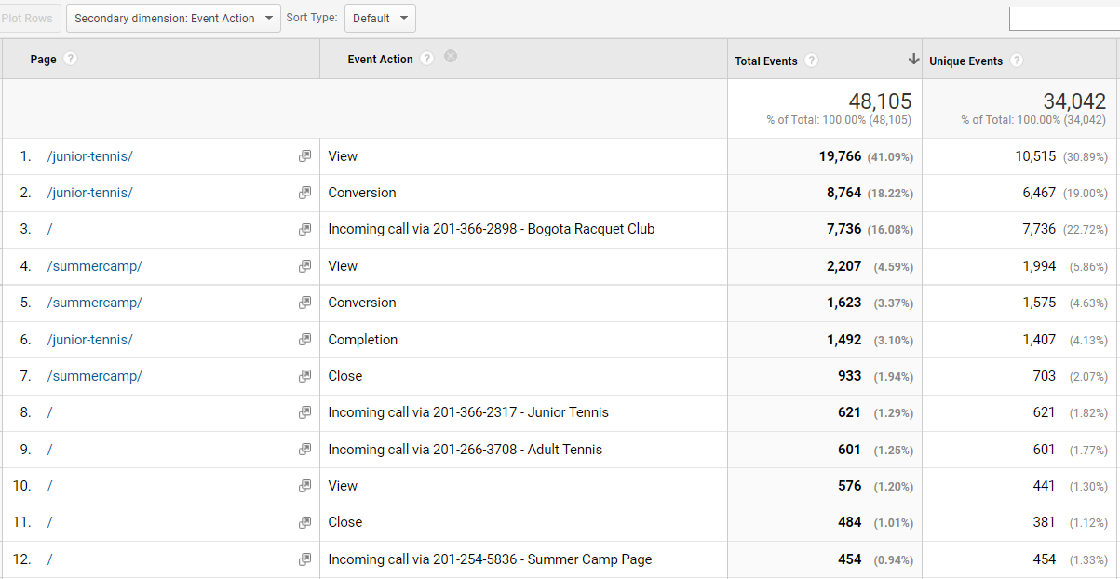

Figure - Event Action per Page

### Google Ads and Benchmarking

Before talking about Google Ads, let’s check the **Benchmarking > Channels** for comparing with the industry. For Industry Vertical we put Tennis, for Region we put New Jersey and Size by Daily Sessions 0-99.From figure 21, it is possible to analyze that CourtSense is doing better in terms of new sessions and new organic and direct users comparing to the industry. Paid search, social media and referral sessions and new users leg behind the competition. Pages per session and average session duration in general leg behind the competition but the bounce rate is 27,90% vs 53,41% of the benchmarked session.

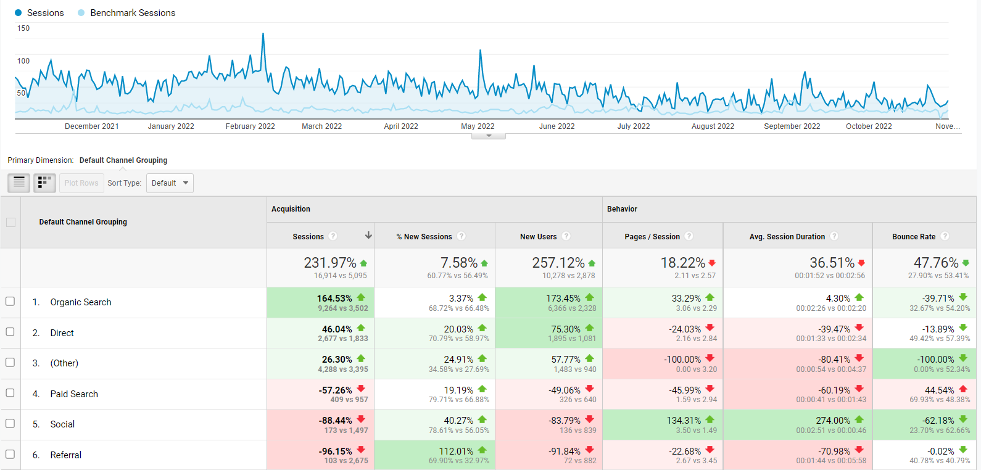

Figure - CourtSense Website performance vs Benchmark Analysis

Regarding the summer camp program, google ad campaign started on the May 8th and ended on the June 30th of 2022, with a cost of **3,941 dollars** and CPC of **2,96 dollars**. Since we do not have access on the Google Ads platform, it is not possible to know what type of campaign it was, since there are a lot of possibilities, such as search, display, performance max or even a video campaign. As we can see on figure 22 the Bounce Rate was too high, showing a bad signal that the traffic was not qualified.

Figure - Summer Camp Campaign Performance Analysis

**What we suggest** is consultation with designers if it is a display campaign, or better understanding your niche with providing better keywords research. In addition, in figures 23 and 24, it is presented the output of our **keyword research**, that was developed through the use of two free tools, the <https://www.wordtracker.com/> and https://tools.wordstream.com/.

The target keywords need to meet four criteria - **significant search volume, high relevance, strong conversion value, and reasonable competition.**

Figure - Keyword Research output from WordTracker

Figure - Keyword Research output from WordStream

## Business Goal 4: Generating revenue through affiliate marketing

Affiliate marketing is a process where publishers earn a commission by promoting a product or service made by another retailer or advertiser using an affiliate link. For example, CourtSense has created a page especially for promoting Play Sight smart court system - <https://www.courtsense.com/smart-tennis-courts/>, but it is not generating revenue. This page has **3,125 pageviews.**

There are many different products that CourtSense can work with that are tennis related. CourtSense can earn money from the user engagement, but at the same time **we suggest** being careful because these banners can slow the page which is not good for the search engines.

If the CourtSense wants to start getting passive income from affiliate marketing they should decide the right product and the right strategy which can be pay per sale, pay per lead, pay per click or pay per install.

### Page Speed Insights

To analyze the page speed, it was used <https://pagespeed.web.dev/>. First Contentful Paint takes 3,5 seconds to load, the Speed Index is 9,5 seconds and the Largest Contentful Paint is 11,6 second. Due to this information, we recommendusing **WebP** and **AVIF** image format and **reduce unused JavaScript**.

### Filters

Since nowadays there are a lot of bots and irrelevant traffic, which is coming from other countries, for example, we recommend using filters and segments. By going to **Admin > Filters**, it is possible to see that there’s a filter called CourtSense Traffic Exclude (figure 25). In the filter there’s an IP address. By checking the IP address 96.57.114.34 in the figure 26, with <https://whatismyipaddress.com/>, it is possible to understand that this is the IP address of the tennis court. It is probably used a lot, so CourtSense don’t want to collect traffic coming from there. Also, a new suggestion is putting other IP addresses, which are the ones that maneuver with GA and the webpage.

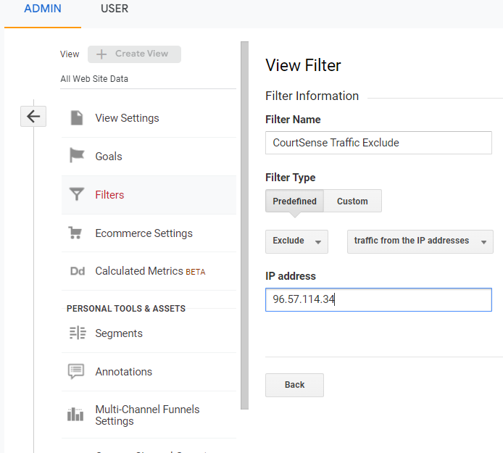

Figure - Google Analytics IP Address View Filter

Figure - Tennis Court IP Address

### Segments

The first and most important benefit of creating Google Analytics segments is that it allows to narrow down broader data to focused on specific subsets, so it is possible to analyze the exact set of data that is intended to measure. For CourtSense, the segments used are presented in figure 27.

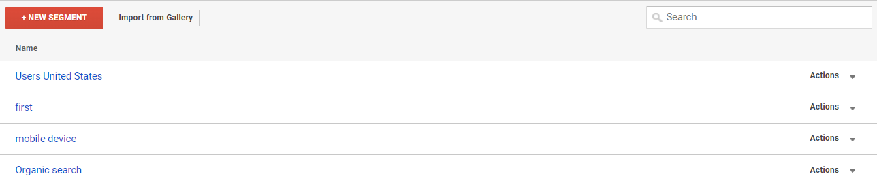The segments correspond to analyze users that are in the United States, sessions between Jul 1st, 2022, and Jul 31st, 2022, people that used mobile devices and people that came to the website through organic search.

Figure - Segments

# Google Looker Studio Report

Looker Studio is a data visualization platform that makes reports easier to create and understand. Here we can see some general with the data that should be improved. We are sharing with you the report also via link: <https://datastudio.google.com/s/oVatTz0ZaP0> A picture containing diagram

# Recommendations

Based on the data provided and our analysis, we have identified several areas for improvement in order to enhance the performance of the CourtSense website. These recommendations are as follows:

1. Improve the conversion rate for the membership packages by optimizing the landing page and the calls-to-action. This can be achieved through A/B testing of different elements such as headlines, buttons, and images. Additionally, consider implementing retargeting campaigns to reach potential members who have already visited the site but have not converted.
2. Launch a paid advertising campaign to promote the new location and increase awareness among potential customers. Utilize targeted ads on social media and Google AdWords to reach users in the surrounding area with an interest in tennis.
3. Increase the number of conversions for the summer-camp programs by fixing the issues with the thank-you pages and implementing a more effective call-to-action. Consider offering a free trial or discounted rate to entice users to sign up.
4. Build a loyal audience through social media channels by consistently posting engaging and relevant content, responding to comments and messages, and using hashtags to reach a wider audience. Utilize Instagram, Facebook, and Twitter to connect with users and encourage them to follow CourtSense for updates and promotions.
5. Explore opportunities for generating revenue through affiliate marketing by identifying relevant products or services that align with the CourtSense brand and target audience. Implement a strategy for promoting these products through banners, sponsored posts, or other methods, and track the performance of these efforts to ensure they are generating positive results.
6. Improve the speed and performance of the website by optimizing images, reducing unused JavaScript, and implementing other best practices for page speed. This will not only improve the user experience, but also help with search engine optimization and overall website traffic.

By following these recommendations and continuing to track and analyze the performance of the website through tools such as Google Analytics, CourtSense can effectively grow its audience, increase conversions, and generate additional revenue through digital marketing efforts.

# Conclusion

In conclusion, our digital analysis of the CourtSense website has identified several areas for improvement in order to achieve the business goals of converting non-members to members, launching a new location, selling summer-camp programs, and building a loyal audience through social media channels.

For the first business goal, we recommended using a combination of blogging, social media, newsletters, and WhatsApp campaigns to guide potential customers through the marketing funnel and encourage them to become members.

For the second business goal, to launch a new location, we suggested creating a new page on the website, launching a paid advertisement campaign with a better design and keyword analysis, launching a newsletter, and placing the new location on Google Maps and Yelp.

For the third business goal, we identified that the summer-camp program page has a high bounce rate and low conversion rate due to the lack of a thank-you page after a user submits their information. We recommended merging the thank-you pages with the buttons on the website to track conversions and improve the user experience.

For the fourth business goal, we think that it may be helpful to conduct further analysis of the website to identify any other potential factors that could be impacting the page speed and revenue generation through affiliate marketing.

Overall, there are several opportunities for CourtSense to improve the performance of their website and achieve their business goals through digital marketing efforts. By implementing these recommendations, CourtSense can expect to see an increase in conversions, new location awareness, summer-camp program sales, and loyal audience engagement.

# Bibliography

1. <https://www.courtsense.com/>
2. <https://analytics.google.com/analytics/web>
3. <https://www.bristolstrategy.com/what-is-an-inbound-marketing-sales-funnel>,
4. <https://seochatter.com/how-important-are-blogs-to-seo/>
5. <https://www.semrush.com/blog/most-popular-social-media-platforms/>
6. <https://vimos.io/>
7. <https://pagespeed.web.dev/>
8. <https://whatismyipaddress.com/>
9. <https://www.wordtracker.com/>
10. https://tools.wordstream.com/.

# Annex

Annex - Audience Demographics - Age (detailed)

Annex - Audience Demographics - Gender (detailed)

Annex - Technology - Top 10 Browser Analysis

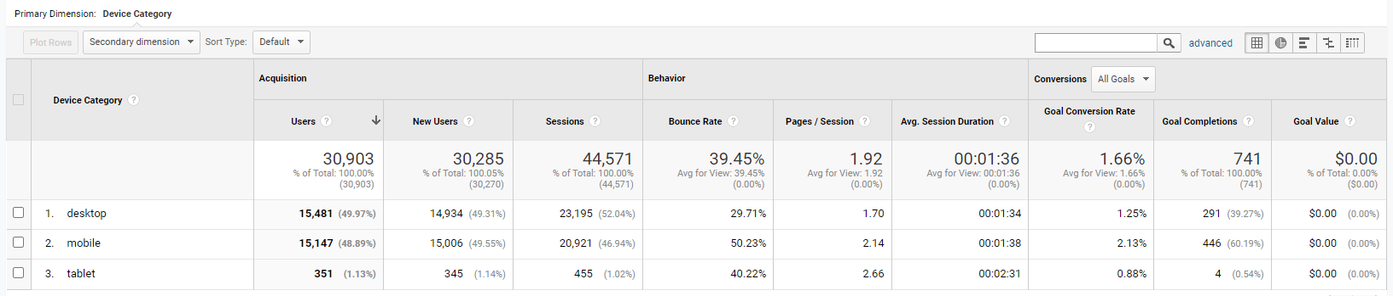

Annex - Technology - Top 10 Device Analysis

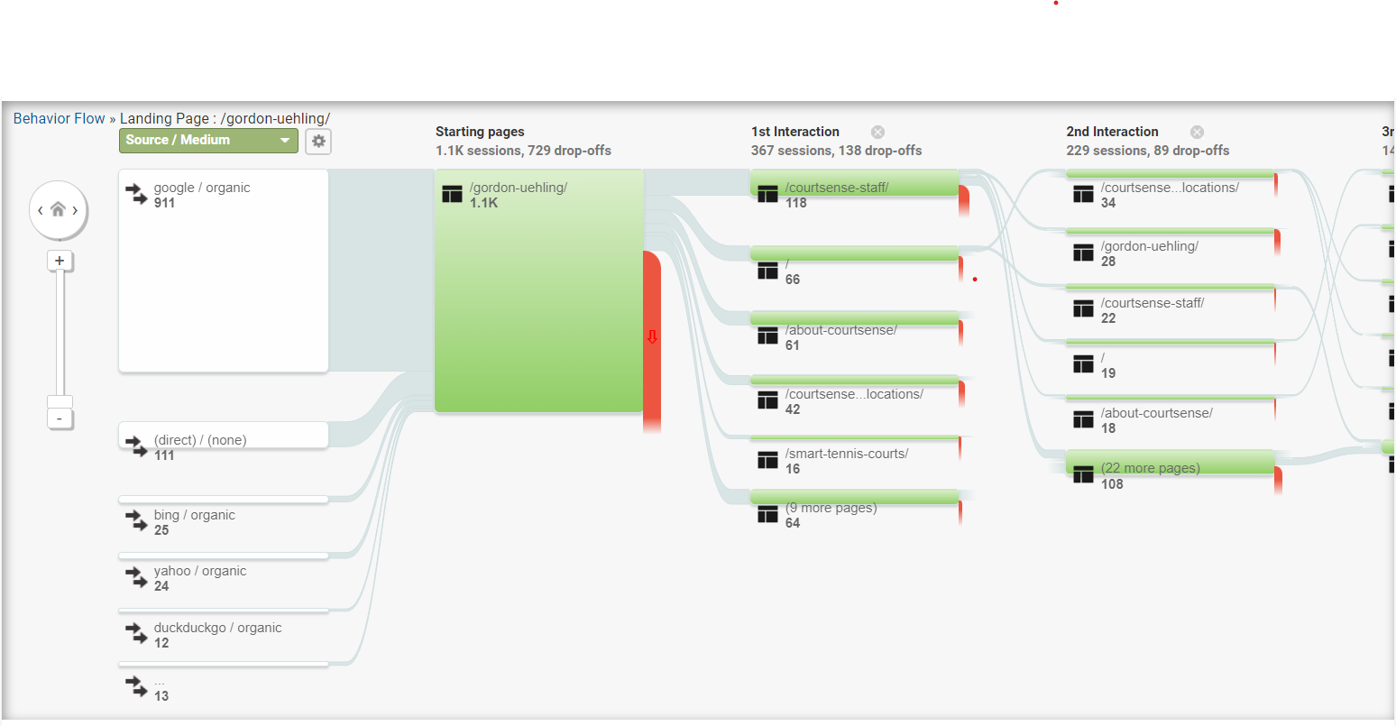

Annex 5 - /Gordon-uehling/ page source